Stress Management and Coping Virtual Field Trips

Elementary School Leaders Supplement – Muscle Relaxation Strategies

When educators WELCOME, INCLUDE, UNDERSTAND, PROMOTE and PARTNER, students have a better sense of belonging at school and can feel confident that there are caring adults in the building and/or virtually to whom they can turn to if they are having difficulties academically, socially, or emotionally.

See also: Leading Mentally Healthy Schools Reflection Tool

The Student Mental Health Action Kit is a collection of resources specifically designed for educators to support student mental health during difficult times, such as the COVID-19 pandemic. As part of this kit, School Mental Health Ontario, in partnership with Ophea, is offering a series of lessons (organized by early years, grades 1-3, 4-6, and 7-8) to support the development of stress management and healthy coping skills. The activities in the lessons provide an opportunity for skill development and modelling for both students and educators. A lesson plan with an accompanying virtual field trip video link will be released each month highlighting a different strategy. With each release, School Mental Health Ontario will add an accompanying school leader supplement to the folder of materials for school administrators to support the school-wide implementation, reinforcement, and modeling of the strategy.

This elementary school leaders supplement supports the principal / vice-principal work to embed evidence-based mental health and well-being in daily practice. At the same time, the school leader is also introducing and modelling evidence-based practices for their staff’s own mental health and well-being.

The school leaders supplement includes ready-to-use materials to support school-wide implementation. These materials include:

- Staff meeting introduction slide deck
- School-wide promotion announcements
- School notification system message
- Newsletter/webpage content

All the materials can be adapted to meet the school leader’s own context within their school/board.

School leader reflection
- How can I ensure that every student has the opportunity to develop their stress management and coping skills? Where is the virtual field trip lesson best introduced in this school (e.g., subject/period)?
- How do we show that embedding these evidence-based mental health and well-being strategies into daily practices are valued in our school?
- In facilitating this lesson/virtual field trip, how am I supporting my staff to explore their personal biases and privileges and how they intersect with their students’ lived experiences and identities? As a school leader, how am I considering and addressing structures that reinforce inequitable conditions that add or exacerbate stress?
- A focus on emotions may be difficult for some students. Consider your school and board circle of support and service pathways. Refer to the ONE-CALL Desk Reference for more information. Know what to do and who to connect with if a student seems like they might be struggling with their mental health.
- How am I modelling the use of these mental health and well-being strategies in my own practice and with my staff?

Questions?
If you have questions about the Student Mental Health Action Kit or implementing mental health promotion and prevention initiatives, you can either connect with your mental health leader or an individual on your board’s mental health leadership team.

Want to learn more?
For more information and resources, please see the School and System Leaders section within of our website. School and System Leaders are also encouraged to enroll in the free online certificate course, MH Lit – Mental Health in Action for school leaders

Implementation materials

Staff meeting introduction
See the accompanying four slide PowerPoint with speaker notes and embedded links. This PowerPoint may be shared with the educators following the staff introduction.

School-wide promotion announcements
- Everyone experiences stress feelings as part of their day to day lives and we can learn ways to manage our stress helpful ways. There are strategies we can learn to help us notice and cope in stressful situations. This month our school is practicing muscle relaxation strategies as one tool to help us through stressful times. Muscle relaxation practices are an example of a useful tool to help us check in with ourselves and cope with big emotions. They can also help improve how our bodies react to stress and help us calm our minds.

- Did you know that muscle relaxation exercise can help us manage stress? Feeling anxious affects our bodies and minds. Strategies that help us recognize when we are feeling stress in our bodies and muscles and help us learn ways to manage stress, can help us feel better in our bodies, which in turn helps calm our minds. This month we are practicing using the muscle relaxation strategies of “Let Go and Stretch”, “Stretch in your Chair” and “Tense and Relax”. Which muscle relaxation practice works best for you?

- [Read by a student or adapted by an adult] Stress is a common part of life. There are things that students experience everyday like schoolwork, getting along with our classmates or worrying about things at home that can make us feel stressed. Stress can affect how we feel about ourselves and how we act towards others. It’s important for us to learn how to cope with stress when we feel overwhelmed. Last month we learned about breathing strategies. This month we are focusing on learning and practicing muscle relaxation strategies as another tool to help us cope with feelings of stress.

- This month, we are focusing on muscle relaxation strategies as one way to help us deal with stress. Which muscle relaxation practice do you find most helpful? I have been practicing [name one – Let Go and Stretch; Stretch in your Chair; or Tense and Relax]. I like this strategy, as it reminds me to relax and decompress. I use this strategy every [morning/day] before… [share an example that is meaningful to you].

- Every day, we deal with big and small challenges that can add to feelings of stress. This month, we have been practicing different muscle relaxation strategies to manage our stress and to improve our ability to cope. Learning these skills is an important part of improving and caring for our positive mental health. If you need further help, ask a trusted adult to help you or call the Kids Help Phone.

School notification system message
At [name of school], we are committed to supporting our children’s mental health. This month we are introducing our students to different muscle relaxation strategies to support their development of stress management and healthy coping skills. Muscle relaxation exercises can help us relax and feel better in our bodies when we are feeling big emotions. Ask your child to share the muscle relaxation strategy that they prefer to use. To view the muscle relaxation strategies, search “Muscle Relaxation Strategies – Virtual Field Trip” on YouTube or by visiting the School Mental Health Ontario website.

Template content for newsletter or website

Supporting student mental health and well-being
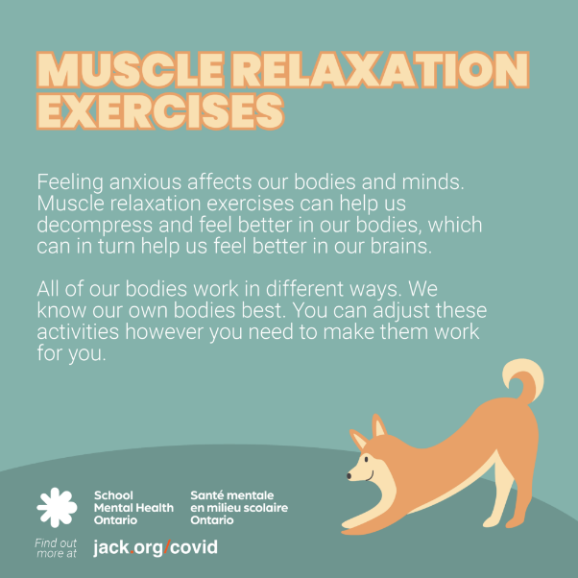
When students attend school, whether in-person or online, they engage in important routines and foster connections that can help them to feel more balanced amidst the uncertainties of the pandemic. Our school is committed to bolstering student mental health and well-being by helping our students explore some ways to manage and cope with stress.

School Mental Health Ontario works together with Ontario school districts to support student mental health. [Name of School] will be using a collection of resources for educators to support student mental health during the ongoing pandemic response. These resources are evidence-based. This month, we will be practicing various muscle relaxation strategies.

Muscle relaxation exercises
Feeling anxious affects our bodies and minds. Muscle relaxation exercises can help us decompress and feel better in our bodies, which can in turn help us feel better in our brains.
All of our bodies work in different ways. We know our own bodies best. You can adjust these activities however you need to make them work for you.

Try the tense and relax exercise
- Squeeze your hands into fists as tight as you can and hold for a few seconds then relax your hands.
- Push your shoulders up to your ears and hold for a few seconds then relax your shoulders.
- Push your heels down into the floor, squeeze your toes and hold for a few seconds then relax your feet.
- Tense your stomach muscles as tight as you can and hold for a few seconds then relax your stomach.

Or follow along with the video:
Try a let go and stretch exercise.
Try a stretch in your chair exercise.
Try a tense and relax exercise.

Please visit the School Mental Health Ontario website for more information for parents and families and practical resources to support student mental health during COVID-19

If you are concerned about your child’s mental health, please contact the school to further support you and your child.

